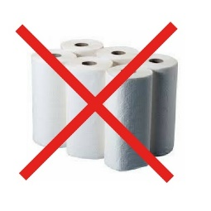
Break the Paper Towel Habit!
Every day, 3,000 tons of paper towel waste are produced in the U.S. alone. To make one ton of paper towels, 15 trees are cut down and 20,000 gallons of water are consumed. Decomposing paper towels produce methane gas and methane gas is a leading cause of global warming. They also leave behind chemicals, bleachers and plastic additives that seep into ground water.

Every year, Americans spend about $5.7 billion on paper towels. An average family could save more than $200 annually and lessen their carbon footprint as well.

Some thoughts:
1. Use reusable cloths…. Start a “rag bag” using worn out clothing, towels etc. or order on-line. Here is a sampling:
A. Amazons Buff Pro multi surface microfiber towels $17/12 pack
B. MioEco Organic cotton reusable paper towels. $1.95/10 pack
C. Geometry.House not paper towels $9/12 pack
D. Zero waste store organic cotton reusable paper towels $24/12

2. When available, always use blow dryers after hand washing in public restrooms.

3. If you must use paper towels, compost them if possible.

Thank you in advance for “greening” your home!
Your Environmental Action Committee

