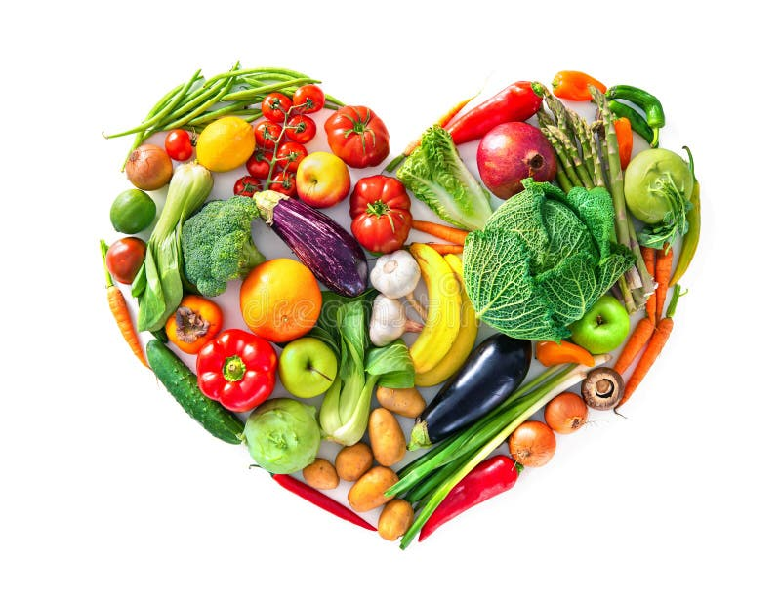

Eating Sustainably
The food we eat has an impact on our health, the environment, and on the welfare of animals and workers.

1. Did you know the average American eats a total of 4.3 pounds of meat per week? Of all agricultural products, beef requires the most land and water, and its production results in the greatest amount of green house gas emissions as well as air and water pollution
What can we do? Substitute plant based meat like “Beyond Beef” or “ Impossible Beef/Sausage,” for beef. These are available with other products in the plant based area of your grocer’s meat case. They are surprisingly tasty as well!

2. Did you know there are 270 million dairy cows in the world? This creates a huge impact on our water and land use, as well increasing greenhouse gas from cow flatulence.
What can we do? Numerous alternatives to cow’s milk are available, such as oat, soy, almond, coconut, cashew, etc. and they are all highly nutritious. You can also find non-dairy creamer, yogurt, cottage cheese, and ice cream.

3. Eating more vegetables can offset the environmental impact of meat and dairy products.
Eat locally grown food, plant a garden and visit farmers’ markets. This can help to lessen the environmental impact by eliminating the pollution from packaging plants and transportation of goods. Locally grown foods tend to be more nutritious, fresher, and tastier.

4. Did you know that the average family wastes 30% of the food they purchase? We can minimize this by:
A. planning meals ahead and not over-buying.
B. not grocery shopping when hungry.
C. freezing or using food before it goes bad.
D. eating leftovers!!
E. composting food scraps.

We can all try to eat more mindfully and thereby lessen our personal carbon footprint.
Submitted by your Environmental Action Committee

