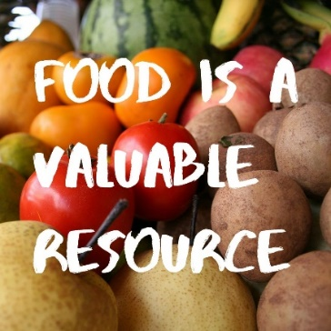
The Facts About Food Waste
The U.S wastes more food than any country in the world…..nearly 80 billion lbs/yr!
That is estimated to be 30-40% of the entire U.S. food supply. Contrast this to the fact that approximately 15 million households are food insecure. People of color are disproportionately affected because of systemic racial discrimination. 22.5% of black and 18.5% of Latinx /Hispanic households are experiencing food insecurity.

The production of wasted food in the U.S. is equivalent to the greenhouse emissions of 37 million cars!

What can we do to help?
1. At restaurants, order only what you can eat or share a meal with someone who is dining with you. Take leftovers home (Using your own containers).
2. Freeze food that cannot be used immediately.
3. Observe and follow “Use by” dates on items and not “Sell by”.
4. Plan meals ahead and make a deliberate grocery list to avoid impulse buying.
5. Avoid “all you can eat buffets”.
6. Keep your refrigerator “clutter free”, so you can see what you have before purchasing more.
7. Eat the skin of many fruits and vegetables which contain a large amount of fiber, vitamins, minerals and antioxidants.
8. Compost all food scraps (no bones), including coffee grounds at your home or use curbside compost service from blueearthcompost.com.

Food is the most frequent component taking up space in landfills. Let’s do our part to change that statistic.
Submitted by your Environmental Action Committee

